

|  |
| --- |
| KICKSTARTER REPORT |
|  |
| May 29  Sherry (Yidan Huang)  UofTSTG20190513DATA |

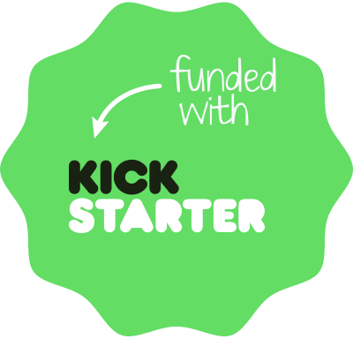

Contents

Background 3

Question 1 – Three conclusions 4

• Conclusion 1 4

• Conclusion 2 5

• Conclusion 3 6

Question 2 – Limitations 7

Question 3 – Other possibilities 8

# Background

Over $2 billion has been raised using the massively successful crowdfunding service, Kickstarter, but not every project has found success. Of the more than 300,000 projects launched on Kickstarter, only a third have made it through the funding process with a positive outcome.

Getting funded on Kickstarter requires meeting or exceeding the project's initial goal, so many organizations spend months looking through past projects in an attempt to discover some trick for finding success. For this week's homework, you will organize and analyze a database of 4,000 past projects in order to uncover any hidden trends.

|  |
| --- |
| Question 1 – Three conclusions Given the provided data, what are three conclusions we can draw about Kickstarter campaigns? Conclusion 1 Among all the parent categories in this study, *Theatre* is the TOP 1 in terms of number of projects indicating that entrepreneurs (fundraisers) in this domain are the most popular and that backers (funders) on the other hand are also favoring this type of projects given its more than 60% success rate. Conclusion 2 When drilling down to sub-categories, *Plays*under parent category *Theatre* represents an even more significant advantage by being the undoubtedly dominating leader in number of project on Kickstarter (*Plays* at 1066 vs. Average per sub-category at only 100). Conclusion 3 The Year Pivot Table shows us the relationship between project outcomes and their launch timing. The earlier the creation date of a project during a year, the higher chance of being successful as outcome. The best timing seems to be May-June since most successful projects appear to have been launched at this time of year. Question 2 – Limitations **What are some limitations of this dataset?**   * The creation dates of this dataset’s projects range from 2009 to 2017 so no newer projects information from the last couple of years can be found in this dataset thus no insight of the more recent trends in the fundraising industry. * This dataset is very heavily focused on American fundraising projects due to the fact that Kickstarter is a fundraising service based in Brooklyn, NY. The number of US projects is 3038 out of the total number of 4114, taking up 73.8% of the whole dataset being studied. Thus its representability of other countries fundraising reality is quite minimal. * As background summary states, Kickstarter’s service has witnessed more than 300,000 projects launch and only a third of those have made it through the funding process with a positive outcome. However in this dataset we studied more than half of the 4114 projects made it to the finish line successfully. Apparently this sample may not match the true Kickstarter fundraising “demographic”.  Question 3 – Other possibilities **What are some other possible tables and/or graphs that we could create?**   * We could create graphs of different project outcomes on a yearly based line chart to determine what year is the most successful which can be done be grouping by year in the row variable of our existing Year Pivot Table as shown below:      * A table analyzing how fast a project reaches or goes beyond its fundraising goal could also be created to include time elapsed starting launch date till ended date in order to check up on its project’s efficiency. * Average donation is an interesting element to take a closer look too since it tells the type of backers supporting a specific project. We can compare average donation with the total goal of a project as well as study the relationship between the average donation and the final outcome of a fundraising project. |